Chapter 15, Problem 31.

Find f(t) for each F(s):

(a) 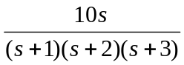
(b) 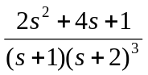
(c) 